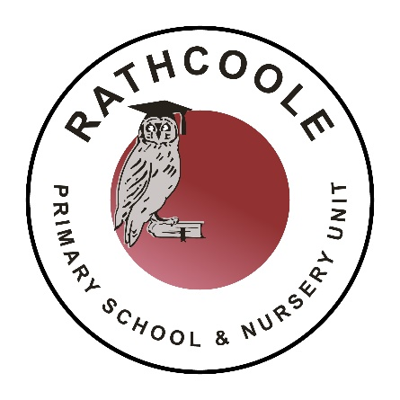
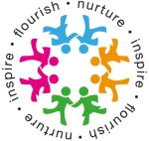

Our Equality and Inclusion Plan
and You

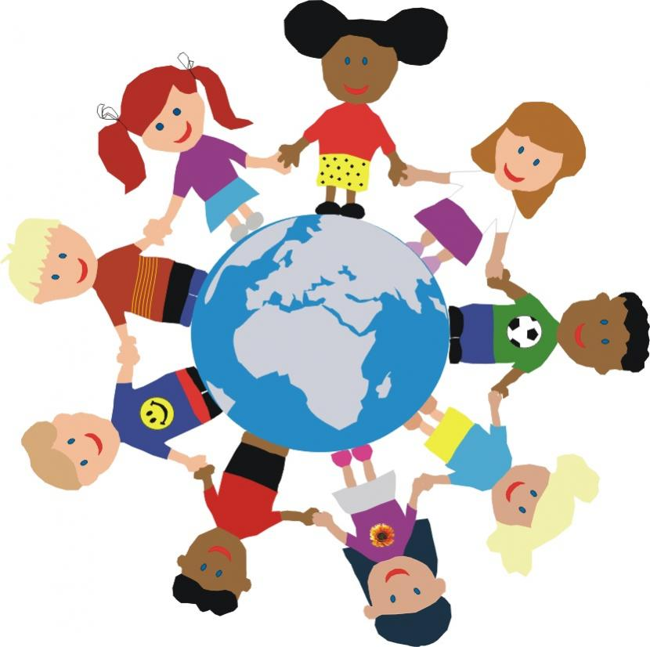
Our School – Rathcoole Primary School and Nursery Unit has promised to be a school that believes difference is important and that values everyone. We want to make sure everyone feels welcomed, accepted and valued.

We are all proud of this school and want to promote all the different cultures, backgrounds, religions and many of the differences you and your classmates bring to this school.

The aim of this plan is to make sure everyone is feeling happy and accepted in school, this makes it more enjoyable for everyone. Understanding the plan and your part in it will help you feel happy and involved in the school community and, most importantly, make new friends with different groups of people. And who doesn’t want more friends!

By helping us with the plan you will become someone who really understands equality and what it means to treat people fairly and with respect. This is something everyone should want as it makes for a good friend, a good pupil and a good person.

You may be thinking that sounds great! How do we bring the plan to our school and how do I become better at understanding all of this?

The answer is by learning some new words, thinking of ways to show those words in our actions and by treating people the way you would like to be treated.

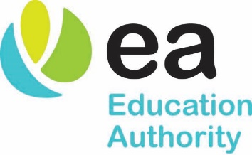

Let’s get started:
The three main words which will make this plan come to life are:
EQUALITY, DIVERSITY AND INLCUSION.

This next part is HOW we use these words to get the plan working in your school.
- We learn the words.
- We understand their meaning.
- We know how to act so the words become actions.

What does that mean?
Equality
This means everyone has the same opportunities no matter WHO they are. You might think it means treating everyone equal but is that always fair if not everyone has the same starting point as you?
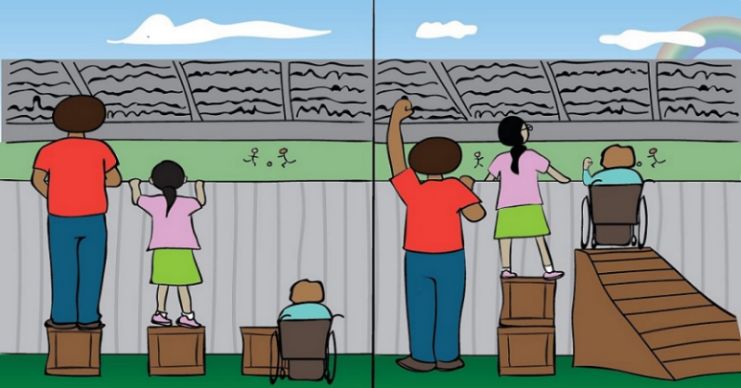

Look closely. Is it fair the person in the wheel chair has to use a box to see out as that’s what the others have? Is it fair the girl can’t see over with just one box? The boy has the best view by simply by being born that way, his experience of watching the football will be better than the others and that isn’t equal.
We have to think of ways to make it equal which isn’t always easy but worth doing it so things are done fairly.

Can you think of examples of how this could happen in school? How about….
- If you are reading a passage (a text from a book) in English class and then writing an answer to a question about the passage, is your classmate from Poland expected to score as high a mark as you, if English isn’t their first language? This is a chance for you to be patient with your classmate and help them when they are stuck.

- It is sports day and your friend with asthma is on your relay race team. They can’t breathe as well as you sometimes, so this might affect how fast they can run. Is it fair to pressure them to be as quick as the others? They maybe don’t have as equal a chance as you to do and this should be respected - differences aren’t always visible which is why we must be kind to others.

Inclusion
This one is easy as the clue is in the start of the word. Inclusion means to include people.
- If you and your friends are about to play football at lunch – did you invite the kid who just moved here from another country and doesn’t have many friends yet? Include them!

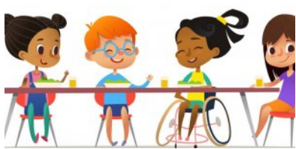
- If you are inviting the whole class bowling for your birthday at the weekend but you are worried your classmate with a disability (something different with their bodies or brains that means they sometimes need extra help) won’t enjoy it as much? Include them!

It is always best to include and invite people and let them decide if they want to join in or not. This is how you make new friends and is the best way to show everyone how kind you are.
Diversity
Diversity is all the different things about people that makes them interesting. If we were all the same and no one was different, there would be no diversity and that would be a bit boring.
So for example:
- If your teacher asks you to form a group to solve a problem in science class - don’t form all boys groups or all girls groups, research tells us that the more diverse a group the better they are at problem solving – it takes all sorts of people and thinking to get you where you need to be.

- At lunch time you might notice children from different countries have totally different packed lunches to what you are used to. Instead of making a fuss as to why they are eating something you’ve never seen before, try being interested in the food and even seeing if you like it yourself. We don’t all have to like the same things and ‘normal’ is different in every culture, this is diversity and we should embrace it.

Our school has some policies in place and it’s up to us to make sure they include everyone and are fair. Also some of the people within the school, such as the Principal, teachers and other staff, it is part of their job to ensure our school is welcoming and open to everyone. But don’t forget – it’s your job too! Let your teacher know if you have any good ideas to include everyone.

That’s it! Now you know the plan for you and our school.

Hopefully you understand these new and important words and they become part of how you live life

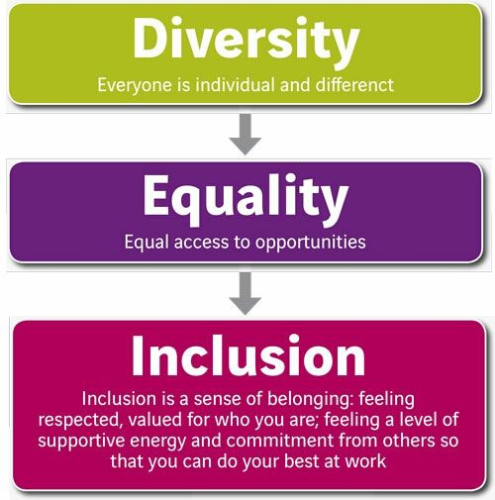

Signed : Emma Quinn (Principal)
Signed : Alison Bennington (Chair of Board of Governors)
Signed : Pupil Council
Date : February 2023

