

Equality & Inclusion Policy


Title | Equality and Inclusion Policy
Summary | This policy sets out your commitment and approach to equality, diversity and inclusion.
Purpose | To ensure that all stakeholders are aware of this policy and its application in relation to equality, diversity and inclusion for all pupils and staff.
Operational Date | Audit to parents – February 2023
Frequency of Review | Every 3 Years
Date last Reviewed and Approved by Board of Governors | June 2024

- Introduction
Rathcoole Primary School and Nursery Unit is a nurturing school, committed to equality and inclusion.
We recognise the value of diverse environments and strive to promote a culture in which all pupils, staff and members of the school community are welcomed and supported to fulfil their potential, irrespective of their background or personal characteristics.
We are committed to an ethos and culture of inclusion in our school for all pupils, irrespective of race, religion/belief, political views, disability, SEN status, gender, gender identity (e.g. transgender) and/or sexual orientation (LGBTQ+).
Rathcoole Primary School and Nursery Unit is an inclusive school where we focus on the well-being and progress of all our children and young people and where all members of our school community are of equal worth and feel safe.
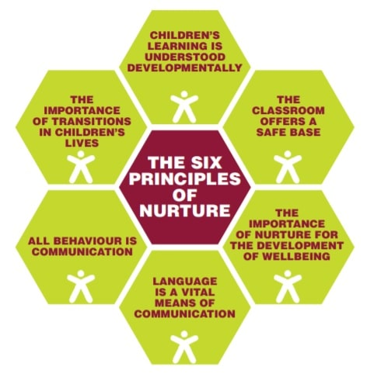
We recognise, respect and value difference and understand that diversity is a strength that enriches our lives. We take account of differences and strive to remove any barriers to learning and development.
As a Nurture School the 6 Principles of Nurture underpin all that we do.
Rathcoole Primary School and Nursery Unit also supports the wider values of the Education Authority of Openness, Respect, Reflection, Responsibility, Excellence and Equality.

We oppose all forms of unlawful and unfair discrimination and bullying and harassment. As a school community, we recognise the need to champion equality and ensure inclusion for all pupils in the full life of our school; where appropriate, making necessary adjustments to enable everyone’s participation.

Rathcoole Primary School and Nursery Unit believes that education (both formal and informal learning) is fundamental to equality of opportunity. It prepares young people for life and is a powerful influence on access to and advancement in employment. All young people should be able to learn and develop fully in a truly diverse and inclusive environment.
All our policies and practices are fully inclusive and supportive of a welcoming culture for all communities; this is evidenced in our practices and procedures.

- Mission and Values
“The Rathcoole Primary School and Nursery Unit family are devoted to ensuring that every child is nurtured and inspired to flourish and achieve in their own unique way. We are proud of our inclusive learning environment, where every child matters, and every voice is heard.” (Ethos statement reviewed November 2021)

“Rathcoole Primary School and Nursery Unit recognises the wider value of education, beyond solely the achievement of qualifications, allowing individuals to develop an understanding and experience of the value and range of diverse cultures, identities and backgrounds. We recognise that Rathcoole Primary School and Nursery Unit is enriched by the diversity that each individual brings and are committed to creating a safe, welcoming environment for all, where each learner can flourish, knowing that differences are respected.” (Diversity Statement – February 2023)


In Rathcoole Primary School and Nursery Unit we follow 3 simple values.
- Be Ready
- Be Respectful
- Be Safe

- Equality and Inclusion – School Policies
Through this policy, and the wider practices within Rathcoole Primary School and Nursery Unit, we seek to empower our young people to embrace diversity and challenge discrimination. We equip our Governors and staff to fulfil their legal responsibilities, ensure that our school’s safeguarding procedures are comprehensive and inclusive and enable robust monitoring of our progress as a school.

Inclusion underpins all our school policies.

As part of our overall school policy development there are a number of policies that we must have in place and regularly review to ensure our school is addressing its statutory responsibilities.

These include
- Pastoral Care Policy
- Safeguarding and Child Protection Policy
- Anti-Bullying Policy
- Positive Behaviour Policy / Relationship Policy
- RSE Policy
- SEN Policy
- ASC Policy
- Communication Policy
- Nurture Approach
- School Development Plan

Any arising incident will be dealt with by the appropriate policy. There should never be any grey areas when it comes to young people’s safety and well-being.

This is supplemented by a range of other policies that as a school we feel are important to have for our whole school community. It is our belief that equality and inclusion is central, to all of our policies and that we maintain an ethos that welcomes diversity and promotes equal opportunities for all, ensuring all our pupils and their families feel valued and supported and making sure that equality and inclusion is evident in everyday school life.

- Responsibilities
The Rathcoole Primary School and Nursery Unit Board of Governors have overall responsibility to:

‘Promote equality, good relations and diversity and to comply with education and employment legislation and anti-discrimination, human rights and equality legislation that affect its statutory duties in relation to the school’ ‘Every school a good school – the Governors role’
(Department of Education NI, August 2019)

The Governors have overall responsibility to manage the implementation of equality and diversity in our school.
The Principal is responsible for:
- ensuring policies and procedures are in place to comply with equality legislation;
- ensuring the school implements policies and practices in line with the principles of equality and inclusion;
- following the relevant procedures and taking action in cases of unfair discrimination, harassment or bullying;
- ensuring appropriate training and awareness raising is undertaken with staff;
- ensuring that appropriate records are kept of any cases of unfair discrimination, harassment or bullying.

The School Senior Management Team are responsible for:
- putting the school’s equality and inclusion policies and codes into practice;
- making sure that all staff know their responsibilities and receive the support and training necessary to carry them out;
- following the relevant procedures and taking action where necessary.

The School’s Pastoral Care and Safeguarding Team (led by the Designated Teacher) will manage the implementation of the policy in partnership with the Principal.

All School Staff (teaching and non-teaching) have a responsibility for the day-to-day operation of this policy and will contribute to an inclusive and welcoming environment within the school.

Pupils/students are responsible for:
- respecting others in their language and actions;
- following all of the relevant school policies and codes of conduct in line with the principles of equality and inclusion.

- How do we promote Equality and Inclusion?

Rathcoole Primary School and Nursery Unit promotes equality and inclusion within our school through the following activities:

School/Centre Practices
- A whole school Nurture approach
- Have an inclusive mission statement
- Use a range of resources and teaching approaches
- Use appropriate terminology and language
- Tackle stereotypes
- Challenge homophobic, transphobic or any other type of bullying
- Set clear expectations about acceptable behaviour
- Nominate a diversity and inclusion champion
- Have Equality and Inclusion as a regular topic at Board of Governor meetings
- Discussing uniform preferences with pupils / students
- We are a Take 5 School
- Trauma Sensitive School – including Solihull trained
- PATHS school
- Work Well – Live Well School (NICHS)
- Restorative Practice
- Bespoke support for children to allow access to learning e.g. sensory needs met
- Bespoke support for children at break and lunch times e.g. quiet lunch room, calm club at lunch.

Policies
- See above for further details

Facilities
- Promoting and using interpreting services
- Using translated documents where available
- Have allocated accessible parking
- Having all accessible toilets/changing facilities
- Having an accessible main entrance and building
- Having signage, displays and resources reflecting all languages and cultures throughout the school
- Considering flexible payment schemes when planning trips and extra-curricular activities
- Helping young people to access advice from support organisations including notice boards with clear and accessible information and contacts

Curriculum
- Examining where and when themes around equality and inclusion might be embedded into topics within each curriculum area
- Holding equality and inclusion themed events on a regular basis and following up on these
- Participating in Shared Education and other programmes
- Ensuring that staff with specific areas of responsibility consider the implications of Equality and Inclusion with their teams

Training
- Regular staff training on wellbeing and mental health
- Supporting staff awareness on issues that impact them e.g. menopause, epilepsy awareness, managing stress, self-awareness support
- Staff trained in whole school Nurture, trauma sensitive practice, Solihull approach, Take 5 whole school approach
- Annual training to support the staff to meet the needs of the children in their care.

- Monitoring the Success of the Equality and Inclusion Policy
The policy will be monitored via a range of methods. We have considered the best methods of monitoring the effectiveness of the policy and out workings, ensuring input from parents, pupils and the school community.
Some methods of monitoring the success of the policy will be :
- Team meetings to have Equality & Inclusion as an agenda item;
- Governors to report on the successes and challenges in relation to inclusion;
- Number of bullying incidents by equality characteristic to be monitored and appropriate action taken as necessary;
- Embedding of equality and inclusion across curriculum areas to be monitored
- Number of comments and complaints in relation to equality and inclusion to be monitored;
- A record of training / information presented to staff/ pupils to be kept
- Positive stories on equality and inclusion to be highlighted
- Feedback from pupils, staff, parents and the wider community to be sought regularly.
- Complaint’s Procedures
The school has a robust and transparent Complaints procedure. If a complaint is made regarding equality or inclusion, the Complaints process will be fairly and systematically applied. Access to the Complaints procedure can be found on the school’s website at https://www.rathcooleprimary.com/complaints/

- Review cycle of policy
The Equality and Inclusion Policy will be reviewed by all stakeholders via surveys and focus groups and, if required, updated every three years in line with our school policy review cycle.

- Any other information

A child friendly version of the policy can be found here
https://www.rathcooleprimary.com/equality-and-inclusion/

A full version to be available on the school website or a paper copy will be issued if required on request.

EA Contact Information

If you have questions about anything in this guidance, or would like further information please get in touch with EA:
Equality & Diversity Unit Tel: 02890 564213
Email: equality.unit@eani.org.uk

Appendix A :
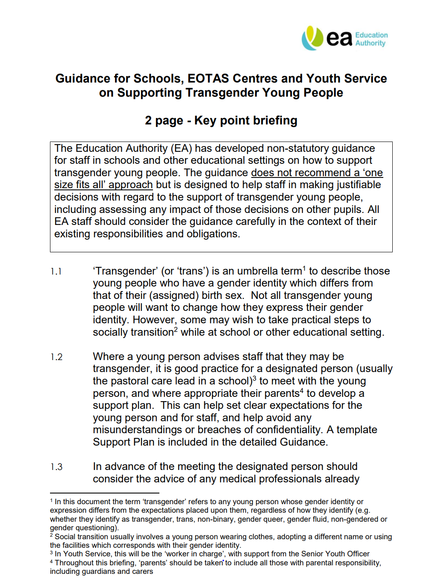
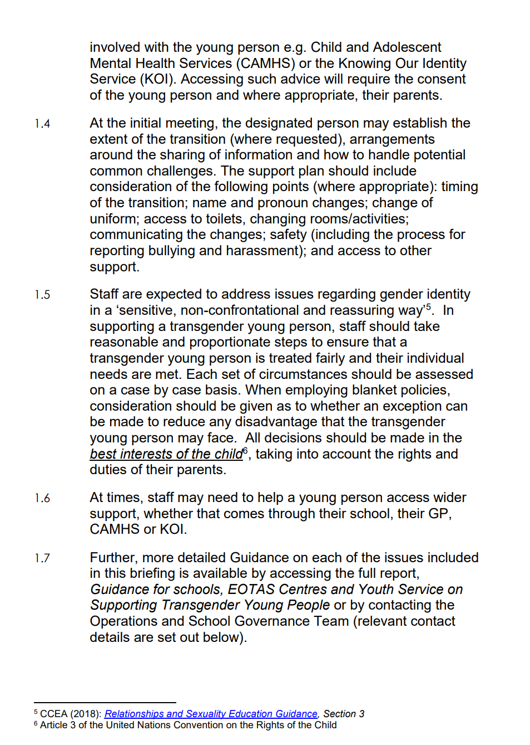

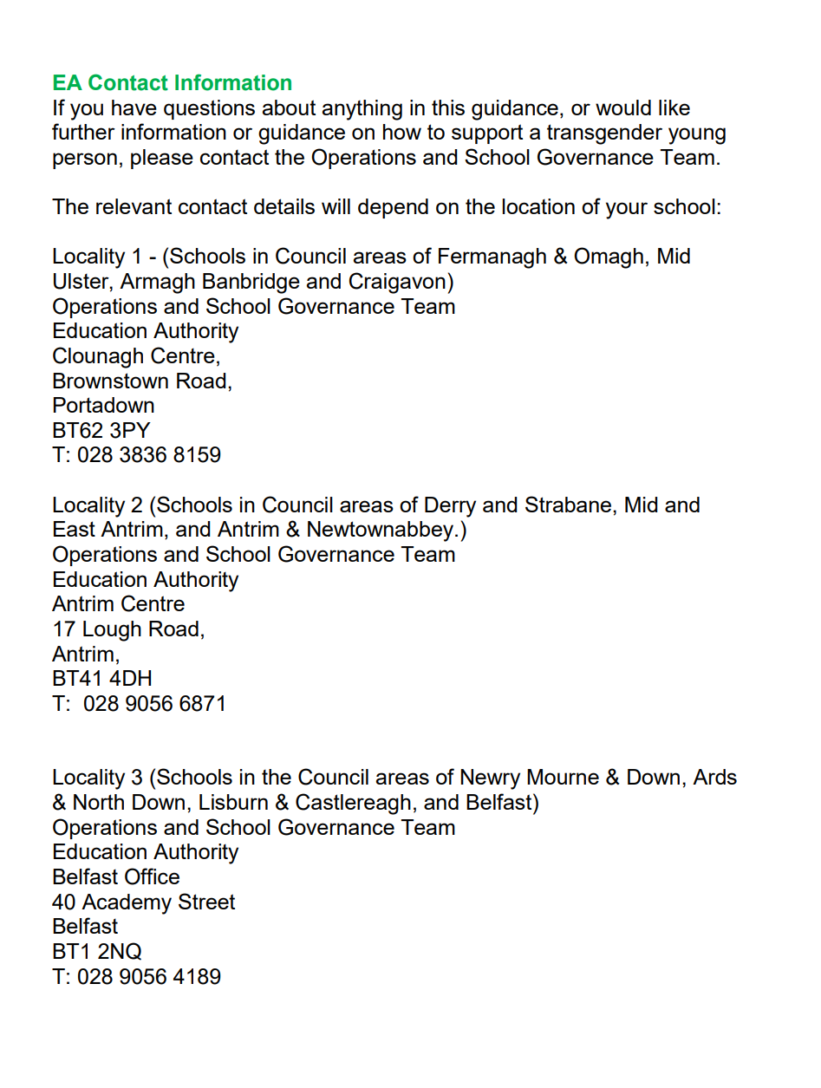

Training Record
Emma Quinn | February 2023 | Online portal
Emma Quinn W | 28th February 2023 | Webinar EA
Whole school staff | August 2024 | Online Portal

